FACE RECOGNITION SYSTEM

END TERM REPORT

*BY*

*GROUP -9*

| SR.NO | NAME | REG.NO | ROLL.NO | MODULE PREPARED |
| --- | --- | --- | --- | --- |
| 1 | SHARAD KUMAR | 11804043 | 36 | MODULE 1 |
| 2 | ADITYA SENGAR | 11804049 | 37 | MODULE 1 |
| 3 | MRITYUNJAY KUMAR MISHRA | 11804112 | 39 | MODULE 2 |
| 4 | AYUSH MISHRA | 11814989 | 56 | MODULE 2 |



Department of Intelligence Systems

School of Computer Science Engineering

Lovely Professional University

APRIL-2020

CONTENT

1.)ABSTRACT

2.)NTRODCTION

3.)LITERATURE REVIEW

4.)PROPOSED METHODOLOGY

5.)RESULT AND DISCUSSION

6.)CONCLUSION

FACE RECOGNITION ABSTRACT

Face (facial) recognition is the identification of humans by the unique characteristics of their Faces. Face recognition technology is the least intrusive and fastest bio-metric technology. It works with the most obvious individual identifier of the human face. With increasing security needs and with advancement in technology extracting information has become much simpler. This system based on face recognition using different algorithms and comparing the results. The basic purpose being to identify the face and retrieving information stored in database. It involves two main steps. First to identify the distinguishing factors in image and storing them and Second step to compare it with the existing images and returning the data related to that image. The various algorithms used for face detection are PCAAlgorithm and Gray Scale Algorithm etc.

INTRODUCTION

Human beings have recognition capabilities that are unparalleled in the modern computing era. These are mainly due to the high degree of interconnectivity, adaptive nature, learning skills and generalization capabilities of the nervous system. The human brain has numerous highly interconnected biological neurons which, on some speciﬁc tasks, can outperform super computers. A child can accurately identify a face, but for a computer it is a cumbersome task. Therefore, the main idea is to engineer a system which can emulate what a child can do. Advancements in computing capability over the past few decades have enabled comparable recognition capabilities from such engineered systems quite successfully. Early face recognition algorithms used simple geometric models, but recently the recognition process has now matured into a science of sophisticated mathematical representations and matching processes. Major advancements and initiatives have propelled face recognition technology into the spotlight. Face recognition technology can be used in wide range of applications. Computers that detect and recognize faces could be applied to a wide variety of practical applications including criminal identiﬁcation etc. Face detection and recognition is used in many places now a days , verifying websites hosting images and social networking sites.

LITERATURE REVIEW

Face recognition is a specific and hard case of object recognition. The difficulty of this problem stems from the fact that in their most common form (i.e., the frontal view) faces appear to be roughly alike and the differences between them are quite subtle. Consequently, frontal face images form a very dense cluster in image space which makes it virtually impossible for traditional pattern recognition techniques to accurately discriminate among them with a high degree of success . Though it is much easier to install face recognition system in a large setting, the actual implementation is very challenging as it needs to account for all possible appearance variation caused by change in illumination, facial features, variations in pose, image resolution, sensor noise, viewing distance, occlusions, etc.

PROPOSED METHODOLOGY

OPENCV-PYTHON(CV2):-For our face recognition system we have created two modules using opencv :-

1.)The first module help us to create a dataframe of images which is prepared by sharad and aditya the code is given below

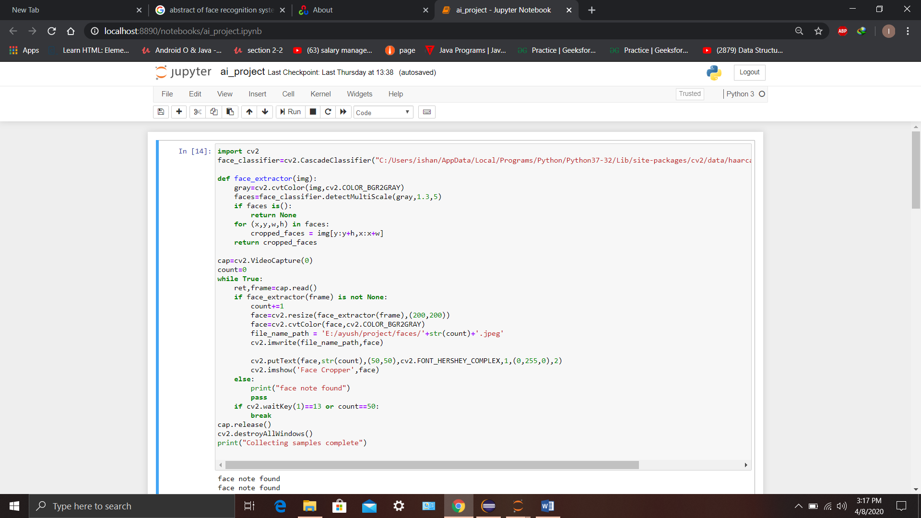

Here we face cascade classifier.We have used face_extractor function to extract face,We are creating a loop and the loop will go until count==50 util then a capture will get open and capture 50 image using our function and store all those 50 image as a data set the variable file_path_name .By these data set we will train our model.

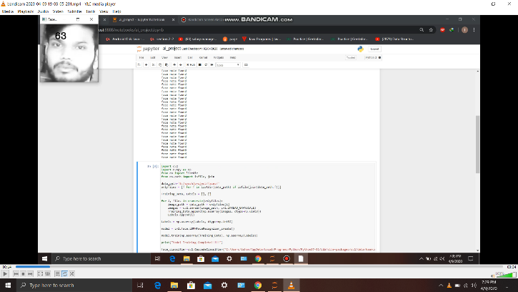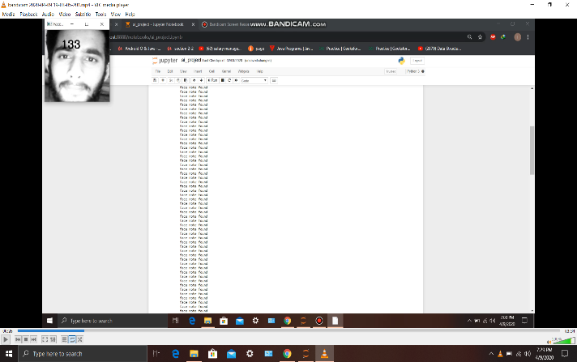

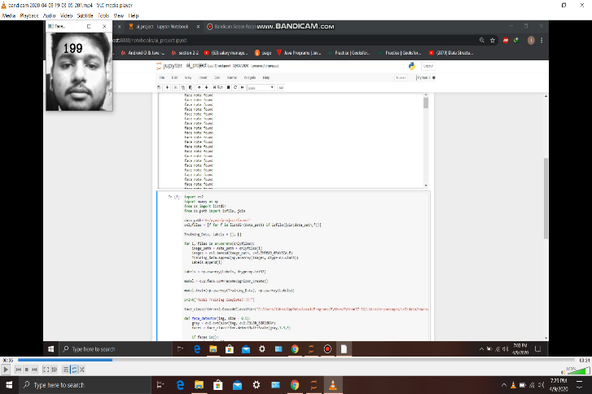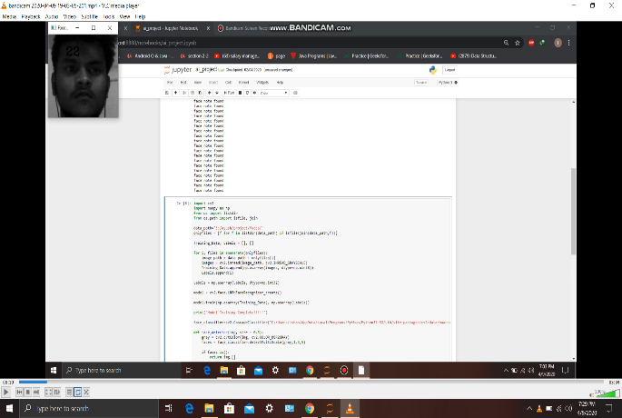

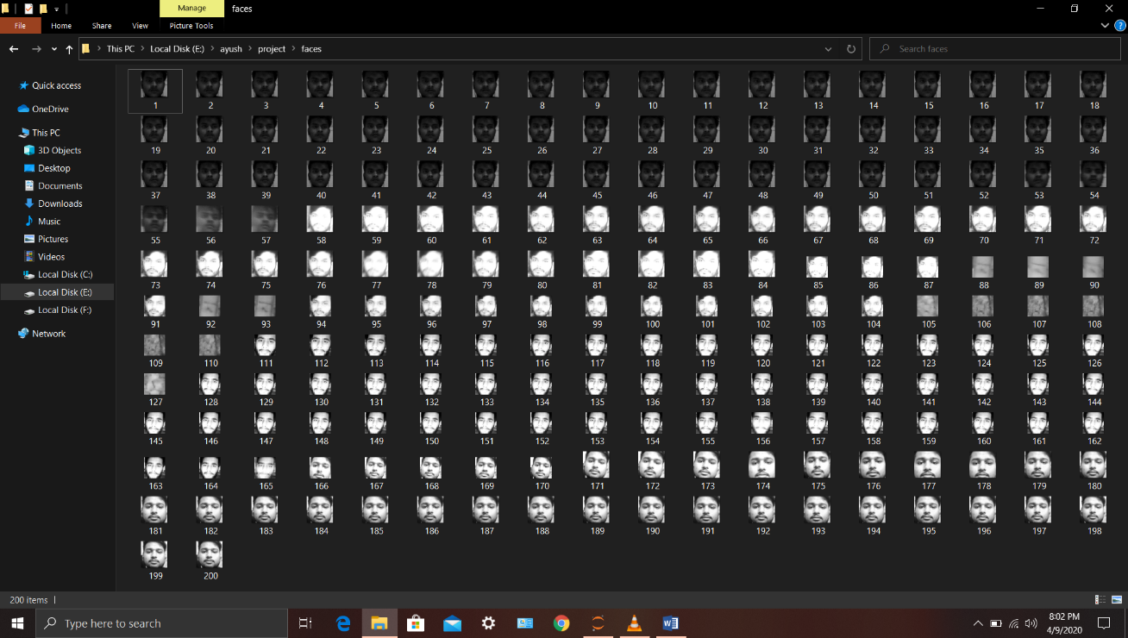DATASET:-

2.)The second module is made by ayush and mrityunjay in wich we train our model and display the result accordingly the result of module 2 is discussed in result and dscussion

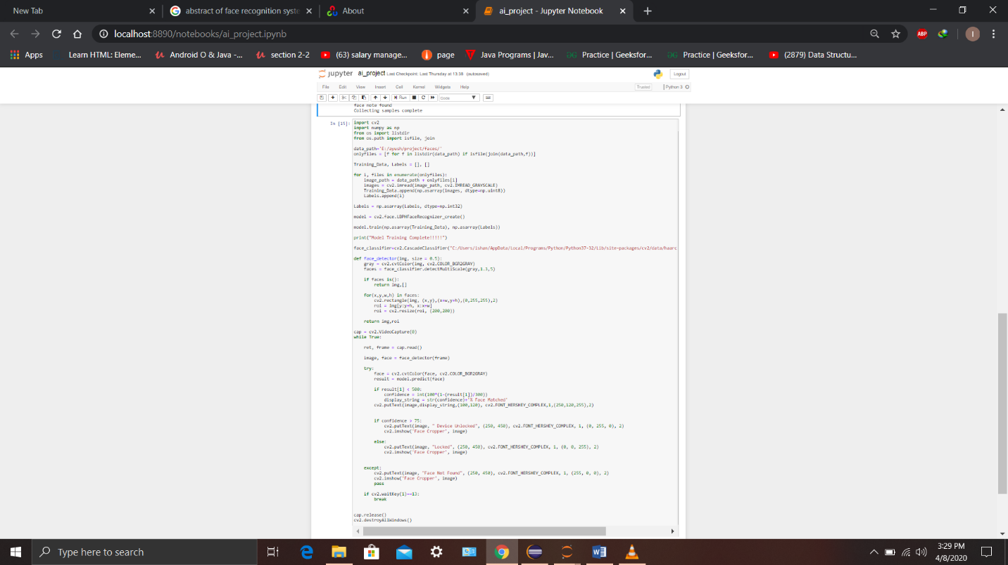

Here first we are training our model by passing the location where our dataset is store when model is trained it will show a message ie Model training Complete!

RESULT AND DISCUSSION

The result will be three:- If the Face I matched with our dataset and the result is more than 75% then the device will get unlocked

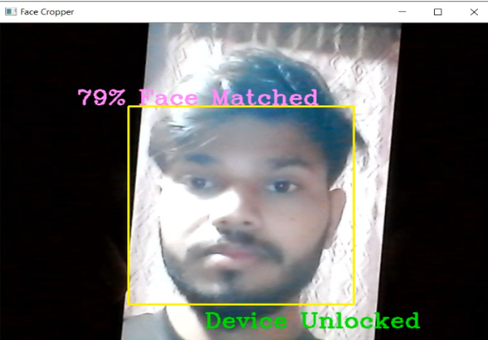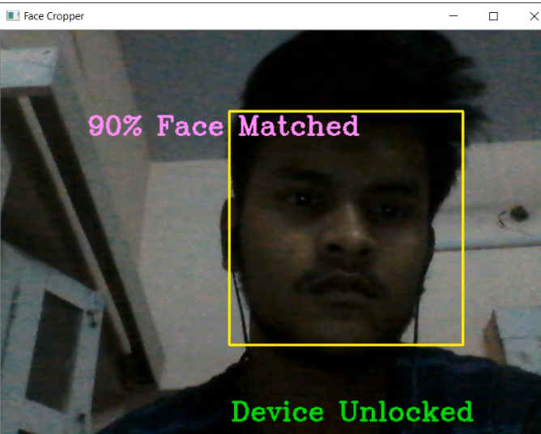

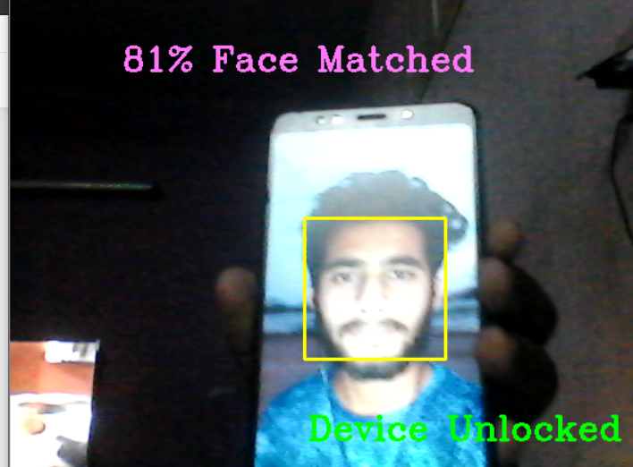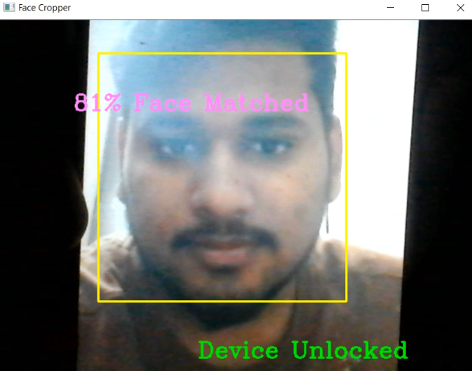

2.) If no face is there or face not clearly visible it will show face not found

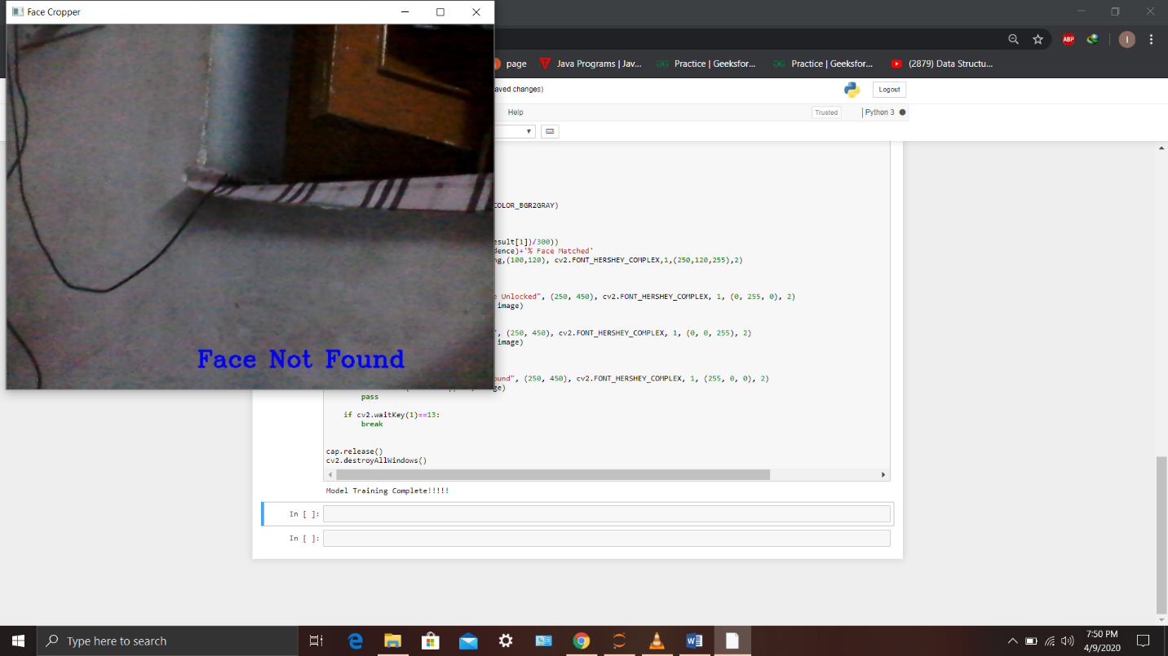

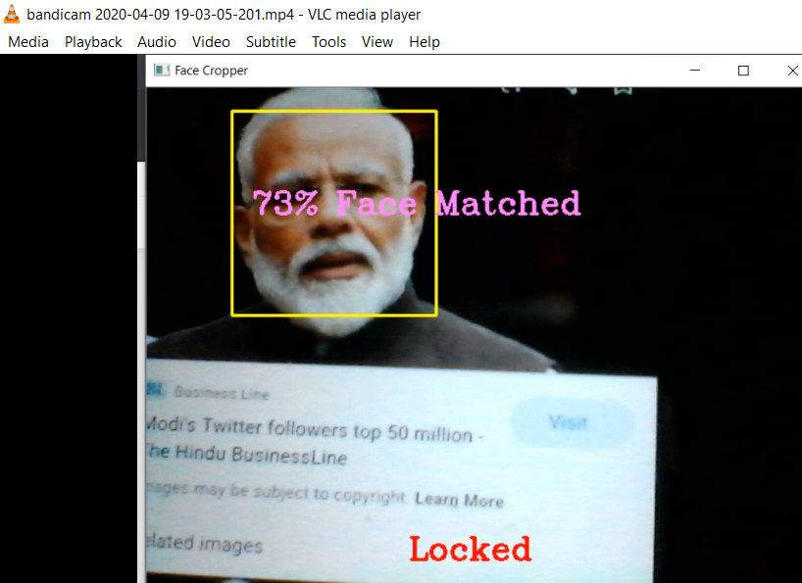3.) If face is found but not matched with our dataset:-

CONCLUSION

Our group has successful worked on this project to make a face recognition system.Our system works absolutely fine,It show the result the matching the face id with our data set stored at particular location and display the result accordingly.Our system also make a rectangle if a face is found. We are glad to work on this project.

THANK YOU